
ESET 462: Control Systems – Spring 2026 Instructor: Isuru Godage, Ph.D.
Lab 6: Report | Discrete Controller Design for Motor Position Control
Section: 502
Student name: Thomas Coyle | UIN: 732007507
Student name: Enrique Venegas | UIN:632008715
Student name: | UIN:

Instructions
• Be concise and limit your responses to the space provided.
• For every image of your assembled circuit (not Simulink model screenshots), ensure your student ID card is clearly visible and legible. This is required for verification purposes.
• Only use the fillable PDF template provided for your report. Do not convert the PDF to another file format, such as Microsoft Word. Doing so will potentially result in a loss of points. • When you are ready to submit, print the PDF file to a new PDF document. The textual content of your final submission must remain selectable and avoid printing the PDF as an image. • Only one submission is required per group. It is every group member's responsibility to ensure that all group members are listed in the Gradescope submission to receive proper credit.
Part 1: Assemble the heating system circuit [5 points]
1. Include a clear, well-lit photograph of the completed circuit on a breadboard. [5 points]
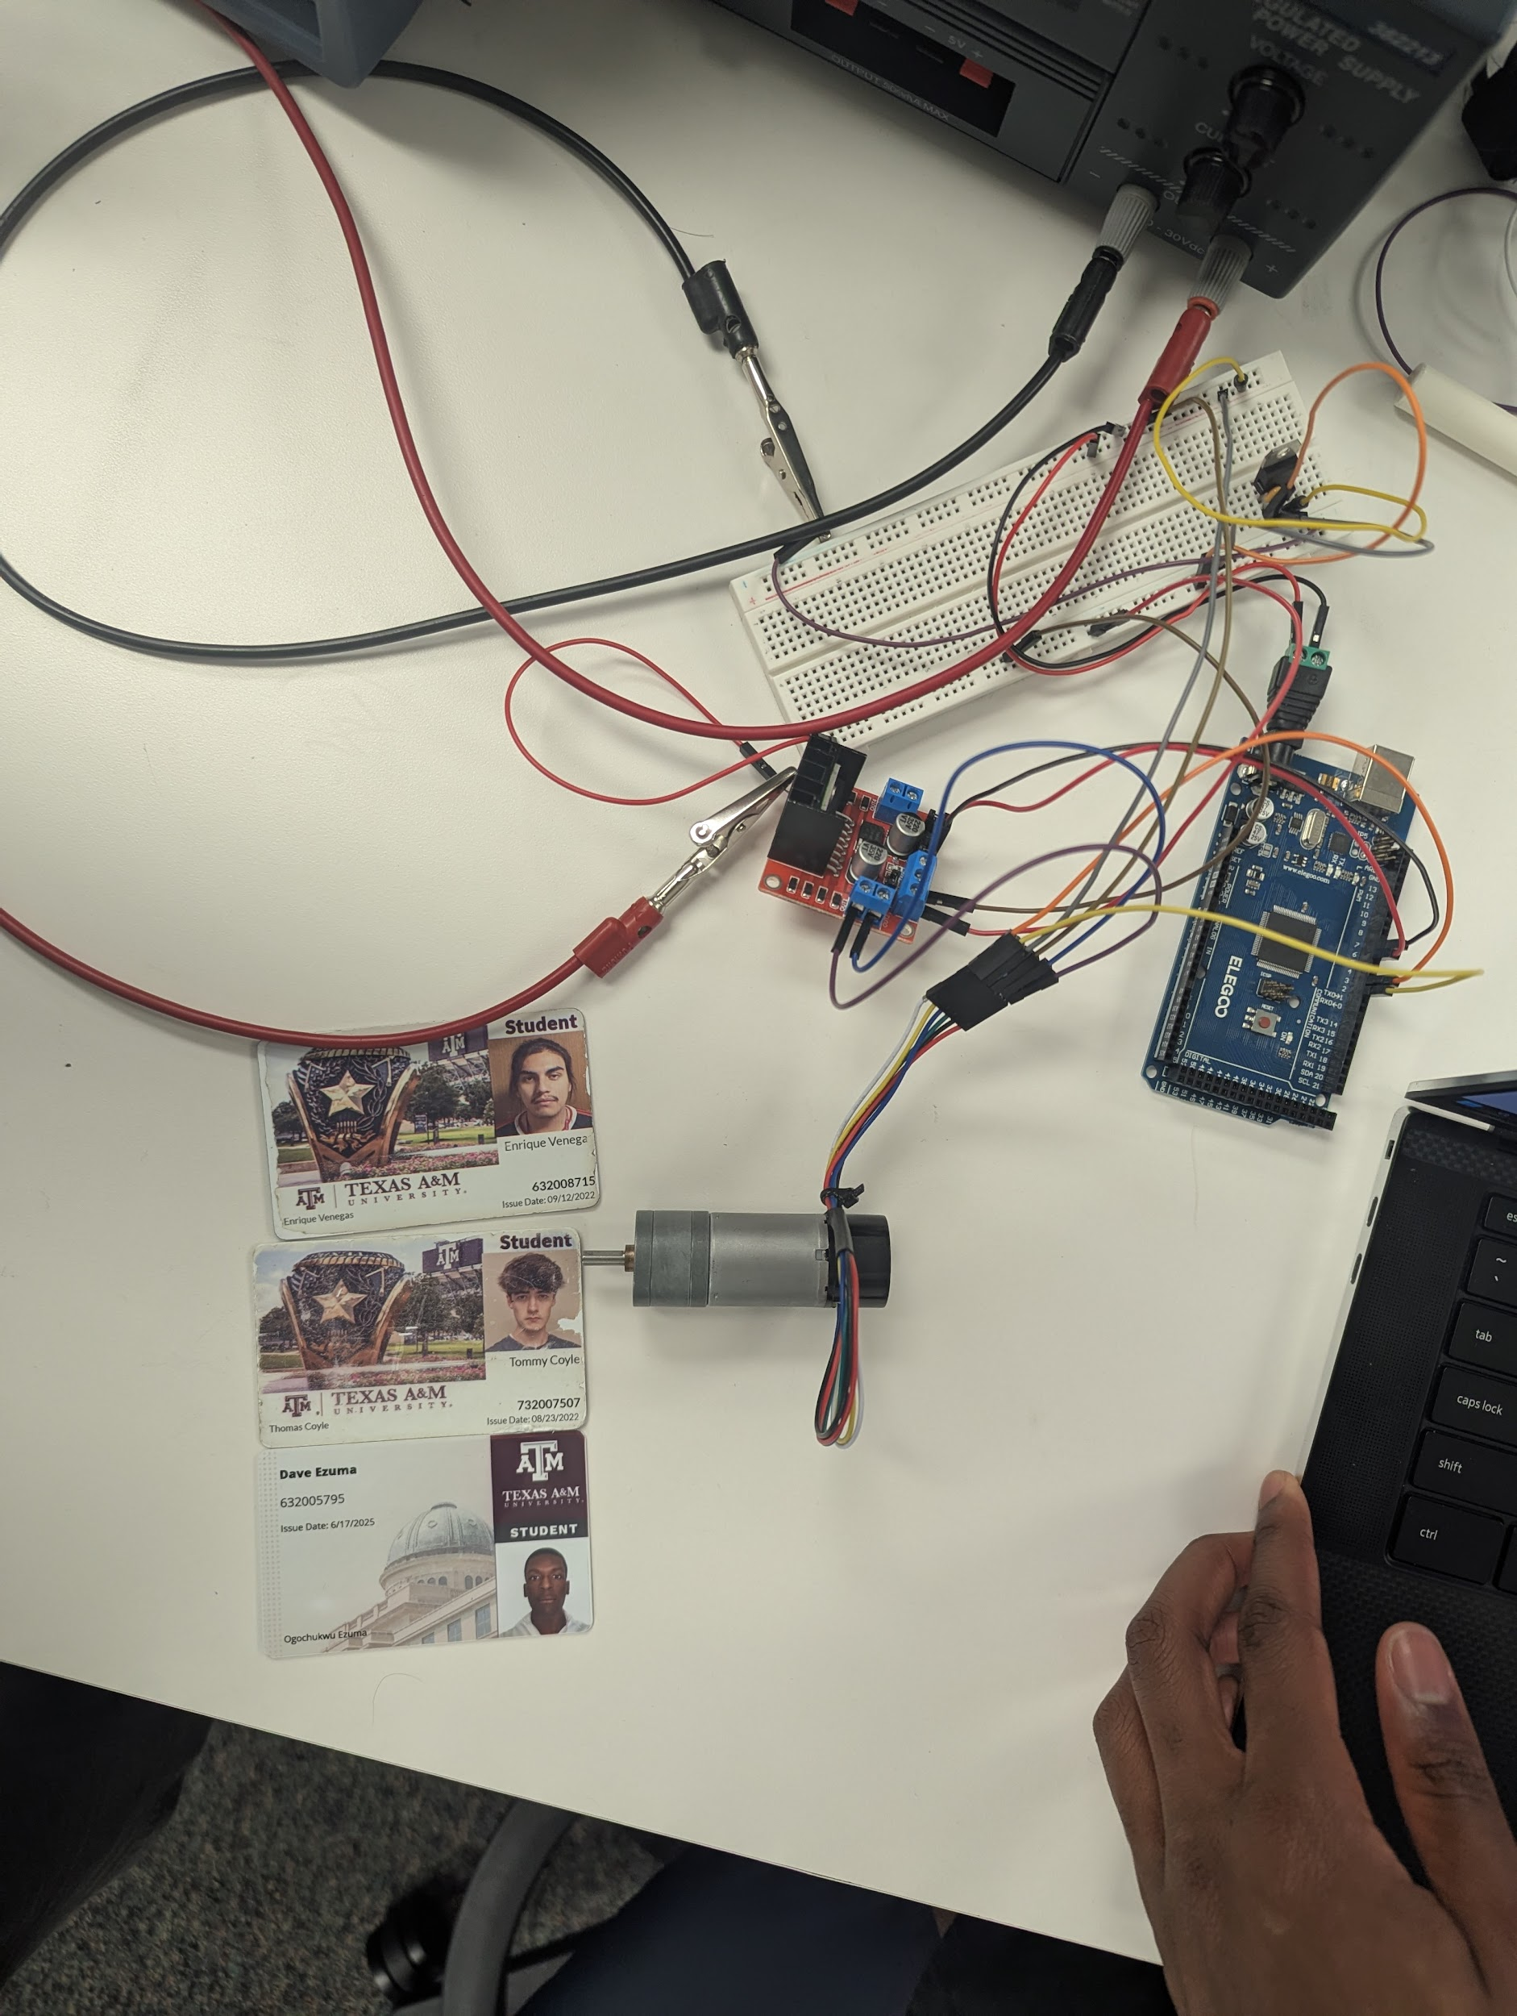

Part 2: System Characterization [30 points]
2. Add a screenshot of the complete Simulink model. [5 points]
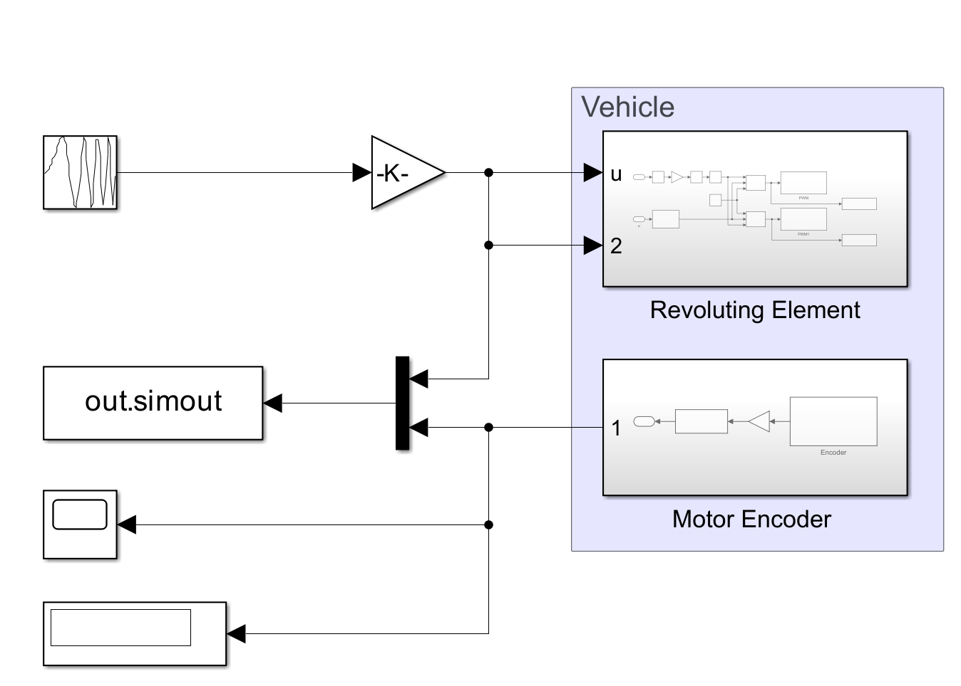

3. Add a screenshot of the system chirp response plot. [10 points]

Discussion
4. What is the reasoning behind using a chirp signal for motor characterization over the step response? [5 points]
The reason for using chirp signal over step response is that chip signals

5. Include a screenshot of the estimated continuous-time domain plant transfer function [10 points]

Part 3: Model Verification [15 points]
6. Include a screenshot of the continuous-time domain model chirp response [10 points]

Discussion
7. Explain the reasoning behind automated transfer function estimation. [5 points]

Part 4: Derive the Discrete Transfer Function [15 points]
8. Include a screenshot of the discrete-time domain model chirp response [10 points]

Discussion
9. Explain the need for discretizing the transfer function. [5 points]

Part 5: Discrete PI, PD, and PID Controller Design & Implementation [35 points]
10. Include a screenshot of the untuned chirp response [10 points]

11. Include a screenshot of the PID turning process (similar to Fig. 16 of the manual) [10 points]

12. Include a screenshot of the serial plotter showing your controller performance [10 points]

Discussion
13. The "Compensator formula" is initially in the z-domain. Why must this be converted to a difference equation (using c(k) and e(k)) before being included in the Arduino script? [5 points]

